Revision Support Information for Parents/ Carers
Students have access to Teams which contains all content taught across all elements and should have a course text book to support classroom learning and revision practise.
Subject | T Level in Education and Early Years (EYE)
Examination Board | NCFE  Information pack - https://www.ncfe.org.uk/media/v3rj05ty/603-5829-4-hei-pack-version-11.pdf
Course Content | Taught Elements:  Element 1: Wider education sector  Element 2: Supporting education  Element 3: Safeguarding, equality and diversity and wellbeing  Element 4: Special educational needs and disabilities (SEND)  Element 5: Child development  Element 6: Working in partnership  Element 7: Professional practice  Core skills:  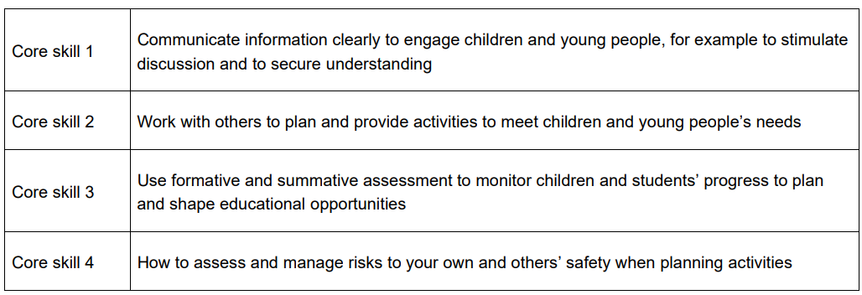
Examination Dates | Employer Set Project (ESP) –  Advanced Assessment Materials 21st March 2026  Project 27th April – 6th May 2024  (15 hours 45 minutes of controlled assessment)  Core Paper – 4th June 2024 AM (2.5 hours)  Specimen Papers –  https://www.ncfe.org.uk/qualification-search/qualification-detail/t-level-technical-qualification-in-education-and-childcare-level-3-delivered-by--377  Core exam grading - https://www.ncfe.org.uk/media/rsdhxry0/notional-boundaries-t-levels-v10.pdf
Resources | Course textbook -  Tassoni, P., Burnham, L. & King, J. (2023) T level Education & Early Years Early Years Educator, London: Hodder Education  Other useful books –  Pendry, A. (2022) The little book of reflective practice. Routledge  Tassoni, P. (2018) Understanding children’s behaviour. Bloomsbury Publishing  Williams. L. (2016) Positive behaviour management in early years settings: An essential guide. Jessica Kingsley Publishers  Useful documents  EYFS - https://assets.publishing.service.gov.uk/media/65aa5e42ed27ca001327b2c7/EYFS_statutory_framework_for_group_and_school_based_providers.pdf  Birth to Five Matters - https://birthto5matters.org.uk/wp-content/uploads/2021/04/Birthto5Matters-download.pdf  National Curriculum - https://www.gov.uk/government/publications/national-curriculum-in-england-framework-for-key-stages-1-to-4  Inclusive Practice – A unique child - https://www.earlyyearsmatters.co.uk/wp-content/uploads/2011/03/eyfs_unique_child_incl_prac1.pdf
Top strategies for final exam preparation (students should already have consolidated course notes and flash cards) | Create end of element posters  Brain dumps/ mind maps  Completing theory sheets  Writing exam answers under timed conditions  Reading model answers  Using past exam questions and planning answers  Marking your own work to a mark scheme  Studying mark schemes  Working with other students in study groups  Comparing model answers against your own work  Creating your own exam questions  Handing in additional work for marking  One to one discussion with teachers  Reviewing feedback/ tips from previous tests/ papers

