Revision Support

Subject | Subject support details
Travel and Tourism | Examination Board https://qualifications.pearson.com/en/qualifications/btec-nationals/travel-and-tourism-2019.html  Unit 2: Global Destinations
Travel and Tourism | Paper 1 – Part A – 6 hours  The 6 hours will commence In your normal lessons from the 13/04/2026  I will go over this in your 1:1  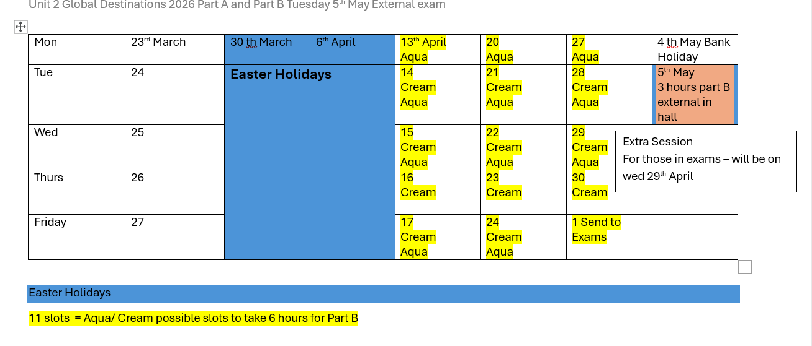
Travel and Tourism | Paper 2 – Part B – 3 hours – Tuesday 5th May 2026- 60 marks available
Travel and Tourism | Exam questions and mark schemes are available via class Teams or the Eduqas website
Travel and Tourism | Key revision/course support:  Revision  - Global Destinations Pearson Active Travel Book has a Global Destinations Unit 2 Page numbers 68 to 118.  Unit 2 Global Destinations Student books –  - Past exam papers, examiners reports and mark schemes. – Teams – Unit 2 Global Destinations – You would be disadvantaging yourself, if you hand not looked at them all, before you exam!  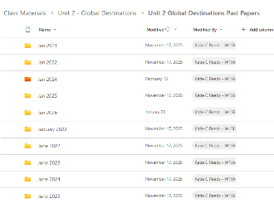  - Presentations on the topic learning aims A,B,C,D,E – Teams Class Materials Independent study  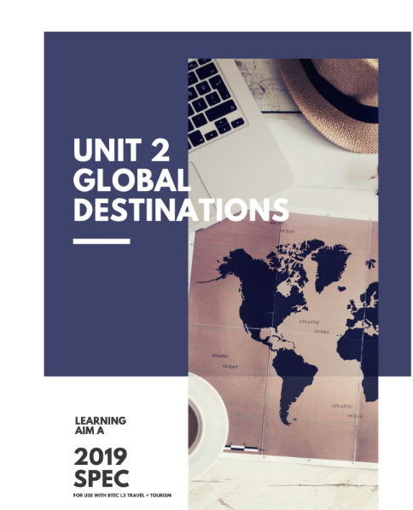  Have you watched the Chief Examiner?  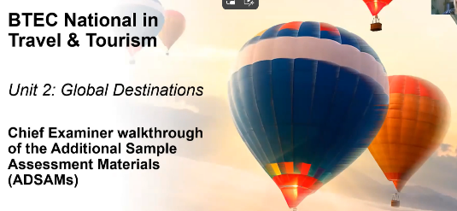  The link is also on the general chat on Teams  https://qualifications.pearson.com/content/dam/pdf/BTEC-Nationals/Travel-and-Tourism/2019/Teaching-and-Learning-Materials/btec-nationals-level-3-in-travel-and-tourism2019-unit-2-chief-examiner-walkthrough-video.mp4  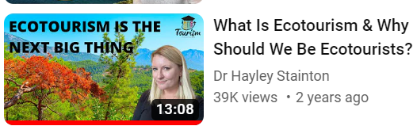  - Dr Hayley Stainton videos on line YouTube will aid revision.  - Unit specification pages 31 – 38 – Unit content headings, lists the topics to revise https://wsfcacuk.sharepoint.com/:b:/s/course-274775-managed-team/EfM7qcvTZ8NLrhOreKm-XJcBGKq3F4Xyc8nehJsFNK02oA?e=NXREha  - Teams – Calander 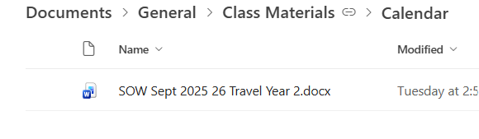  - Here you can find all the PowerPoint presentations for the units
Travel and Tourism | Top strategies for final exam preparation  • Writing exam answers under timed conditions  • Reading model answers – Use AI  • Using past exam questions and planning answers  • Marking your own work to a mark scheme  • Studying mark schemes or examiner’s reports  • Comparing model answers against your own work  • Creating your own exam questions – use the specific Travel and Tourism language in your answers. Use PEEL –( see teams general for PEEL)
Part A Research
- Don’t use Wikipedia
Good sources for information
- https://www.ttgmedia.com/
- https://www.travelmole.com/
- https://www.abta.com/industry-zone/reports-and-publications/abta-travel-trends-reports

